Fig. S8

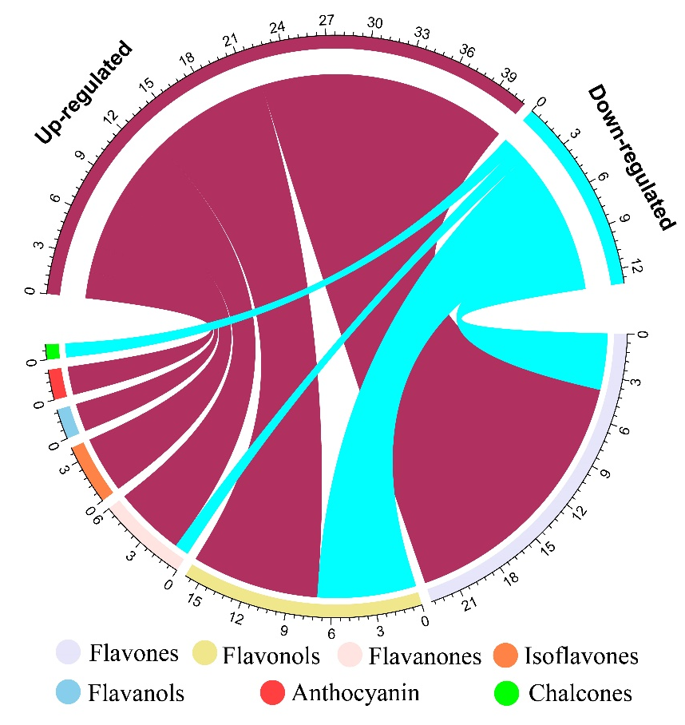

Additional file 1: Fig. S8 Circle graph of seven subcategory flavonoid metabolites in P deficient stylo roots. Digital scale represents the number of corresponding metabolites. Up-regulated or down-regulated metabolites were screened according to the criterion of fold changes ≥ 2.0 or ≤ 0.5, and VIP ≥1.0 (n = 3).

